PYTHON LAB PROJECT REPORT

Project: Python Lab Project
Student Name: Melchizedek Ebenyo
Date: 22 August 2026

Project Overview
This project shows how to build a Python application with Git and GitHub. The Python project was split into files and functions. It was tested on the machine committed to Git and then pushed to GitHub.

Project Structure
The Python project has the following main parts:
docs. Contains project documentation.
src. Contains the Python source code.
main.py. Contains the program.
utils.py. Contains reusable utility functions.
.gitignore. Specifies files that should not be tracked by Git.
LICENSE. Contains the project license.
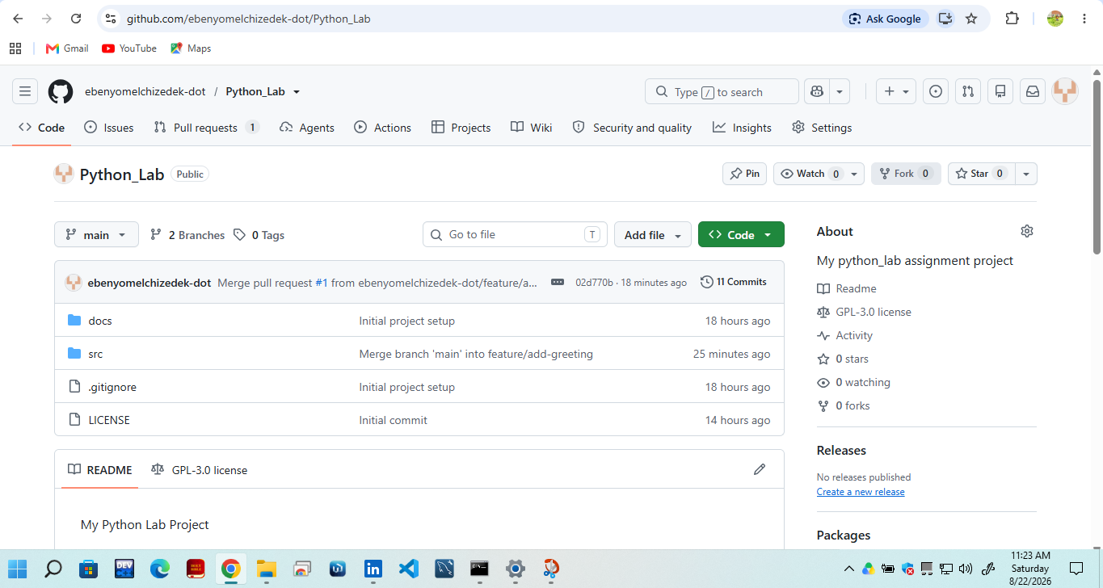
GitHub repository structure showing the project files.

Utility Functions
The utils.py file holds functions that the main program calls. These functions are:
square(). Calculates the square of a number.is_even(). Determines whether a number is even.celsius_to_fahrenheit(). Converts Celsius to Fahrenheit.greet(). Produces a greeting.
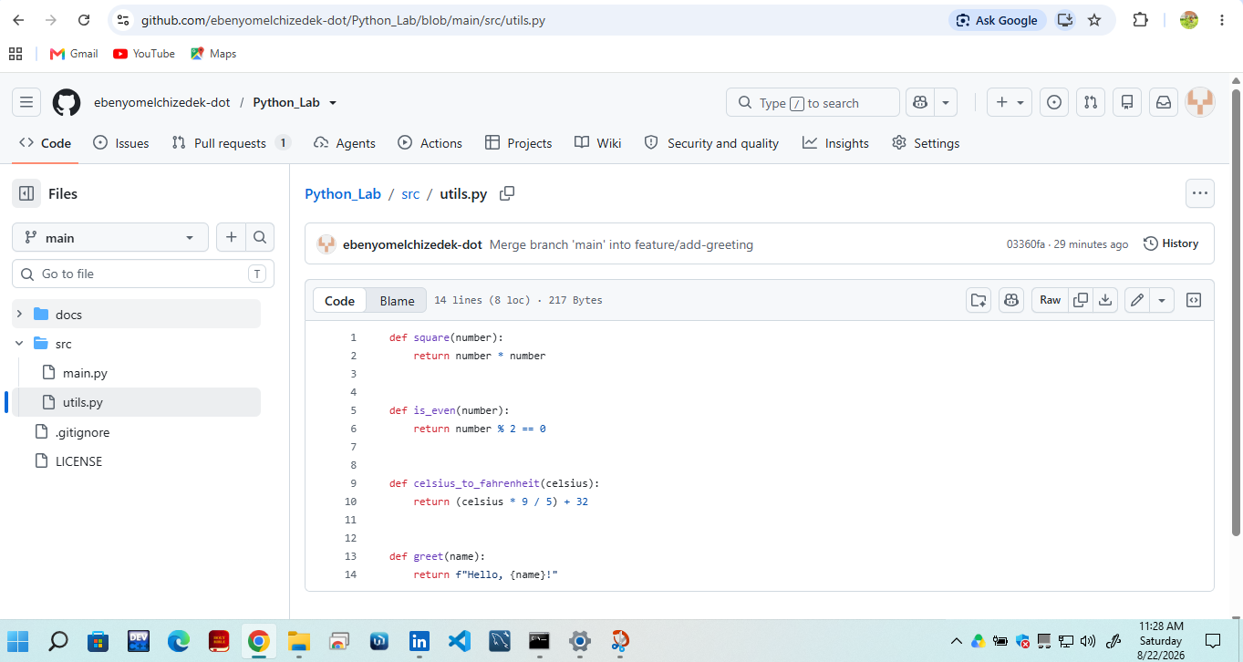
Utility functions implemented in utils.py.

Main Python Program
The main.py file imports the utility functions. Uses them in the main program. The program takes user input. Shows the results, including a personalized greeting.
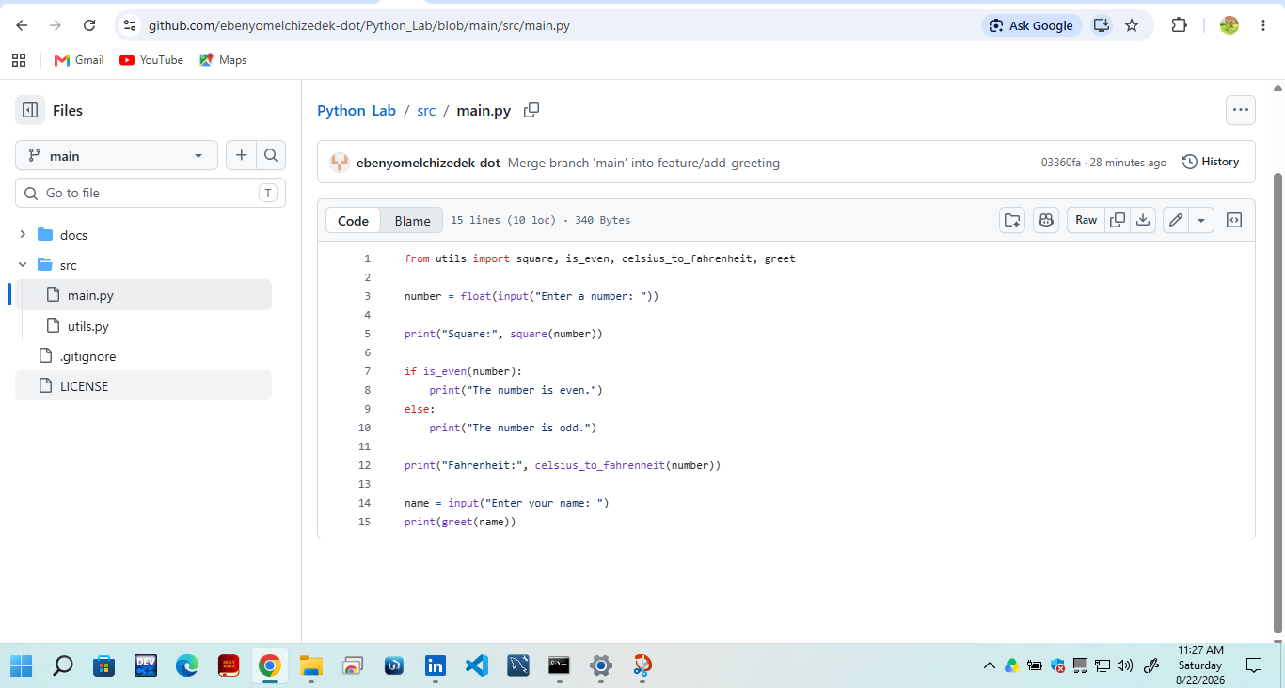
Main Python program, in main.py.

Program Testing
The program was run from Command Prompt with:
python src\main.py
The program was tested with user input and produced the expected calculations and a personalized greeting.
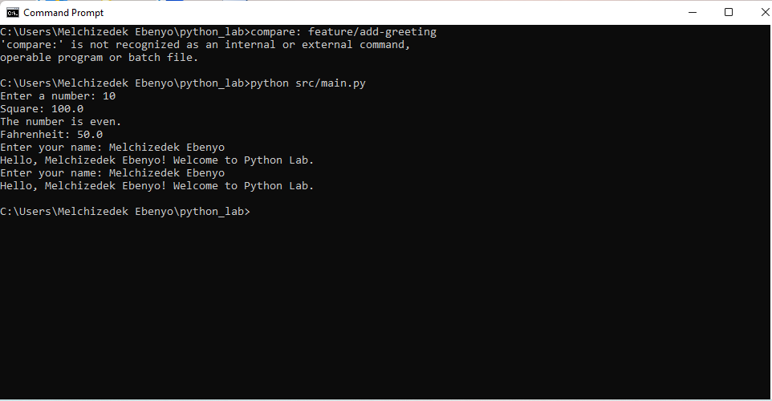
execution of the Python program.

GitHub and Pull Request
The Python project was uploaded to GitHub. A separate branch named feature/add-greeting was created to add the greeting feature.
A Pull Request was then made to merge the feature branch into the branch. The Pull Request was merged into the branch.
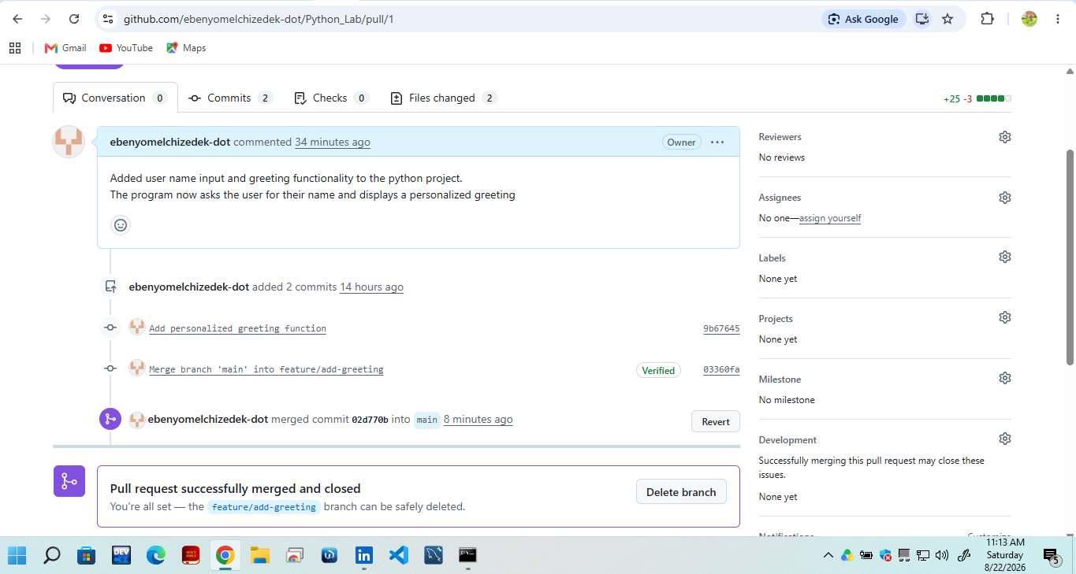
Pull Request successfully merged into the main branch.

The Python project showed how to use Python programming, functions, Git version control, GitHub repositories, branches, commits and Pull Requests. The final Python project was. The greeting feature was added to the main branch.

